Carnegie Institution of Washington
Department of Terrestrial Magnetism

Legacy Cosmic-Ray Data

1935-1960

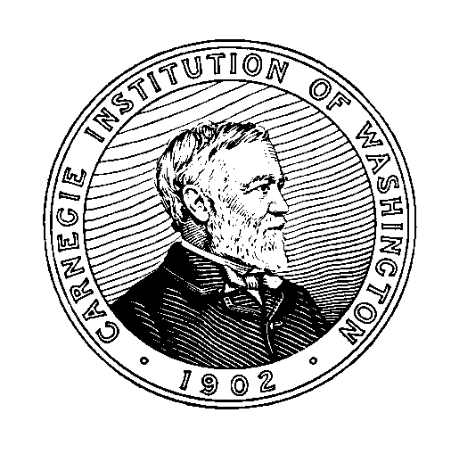

compiled by Shaun J. Hardy

July 2006

Introduction

The Department of Terrestrial Magnetism (DTM) of the Carnegie Institution of Washington operated a worldwide network of recording ionization chambers from the 1930s through the 1970s under the supervision of Dr. S. E. Forbush.

Over a two-year period beginning in June 2004, at the Department’s request, Dr. Kenneth G. McCracken examined the “archive” of Forbush’s data preserved at DTM. He prepared a detailed assessment of their possible scientific value, recommendations on their preservation, and notes to aid researchers in their interpretation. These are presented in a separate report.

Based on Dr. McCracken’s recommendations, arrangements were made to transfer to the National Geophysical Data Center all of the ionization chamber photographic records and station operator logbooks for the period 1935-1960, together with a small sample of data worksheets. A container list follows. Other material in the collection was deemed not to merit further preservation and was disposed of.

Station Coordinates

Cheltenham Magnetic Observatory, Maryland, USA
latitude 38°.7 N, longitude 76°.8 W, elevation 72 m.

Christchurch Magnetic Observatory, New Zealand
latitude 43°.5 S, longitude 172°.6 E, elevation 8 m.

Fredericksburg Magnetic Observatory, Virginia, USA
latitude 38°12’ N, longitude 77°22’ W, elevation 69 m.

Godhavn Magnetic Observatory, Greenland
latitude 69°.2 N, longitude 53°.5 W, elevation 9 m.

High Altitude Observatory, Climax, Colorado, USA
latitude 39°.37 N, longitude 106°.18 W

Huancayo Magnetic Observatory, Peru
latitude 12°.0 S, longitude 75°.3 W, elevation 3350 m.

Universidad Nacional de Mexico, Instituto de Geofisica, Mexico
latitude 19°20’N, longitude 99°11’ W, elevation 2267 m.

Container List of Ionization Chamber Records

Box Number Contents

DTM-CR-1 Huancayo photographic records, 1936-1948

DTM-CR-2 Huancayo photographic records, 1949-1960

DTM-CR-3 Cheltenham/Fredericksburg photographic records, 1935-1946

DTM-CR-4 Cheltenham/Fredericksburg photographic records, 1947-1960

DTM-CR-5 Christchurch photographic records, 1936-1950

DTM-CR-6 Christchurch photographic records, 1951-1959;
Mexico photographic records, 1954-1959

DTM-CR-7 Godhavn photographic records, 1938-1950

DTM-CR-8 Godhavn photographic records, 1951-1959

DTM-CR-9 Climax photographic records, 1949-1959

DTM-CR-10 Christchurch and Godhavn journals (station logbooks); sample hourly data and scaling details

DTM-CR-11 Cheltenham, Climax, Huancayo, and Mexico journals (station logbooks); sample data from Cheltenham

Published Compilations of DTM Cosmic-Ray Data

Beach, L., and S. E. Forbush, Cosmic-Ray Results, Huancayo, Peru, January 1956-December 1959; Cheltenham, Maryland, January 1956-October 4, 1956; Fredericksburg, Virginia, October 5, 1956-December 1959; Christchurch, New Zealand, January 1956-June 1959; Godhavn, Greenland, January 1954-July 1959; Universidad Nacional de Mexico, July 1957-December 1958, Carnegie Institution of Washington Publication 175, vol. 21, Washington, DC, 1961. 226 pp.

Beach, L., and S. E. Forbush, Cosmic-Ray Results, Huancayo, Peru, January 1960-December 1968; Fredericksburg, Virginia, January 1960-December 1968; Christchurch, New Zealand, January 1959-December 1961; Godhavn, Greenland, January 1951-December 1953, Carnegie Institution of Washington Publication 175, vol. 22, Washington, DC, 1969. 311 pp.

Lange, I., and S. E. Forbush, Cosmic-Ray Results from Huancayo Observatory, Peru, June 1936-December 1946; Including Summaries from Observatories at Cheltenham, Christchurch, and Godhavn Through 1946, Carnegie Institution of Washington Publication 175, vol. 14, Washington, DC, 1946. 182 pp.

Lange, I., and S. E. Forbush, Cosmic-Ray Results, Huancayo, Peru, January 1946-December 1955; Cheltenham, Maryland, March 1936-December 1955; Christchurch, New Zealand, January 1947-December 1955; Godhavn, Greenland, January 1947-December 1950, Carnegie Institution of Washington Publication 175, vol. 20, Washington, DC, 1957. 224 pp.

[Copies of the above publications are available to interested researchers at no charge by contacting the Librarian, Department of Terrestrial Magnetism, 5241 Broad Branch Road, N.W., Washington, DC 20015]

