The National Solar Observatory (NSO) has provided the National Geophysical Data Center (NGDC) with a full set of daily solar sunspot drawings prepared by the Sacramento Peak (Sac Peak) Solar Observatory. There are dates that have no data available due to weather.

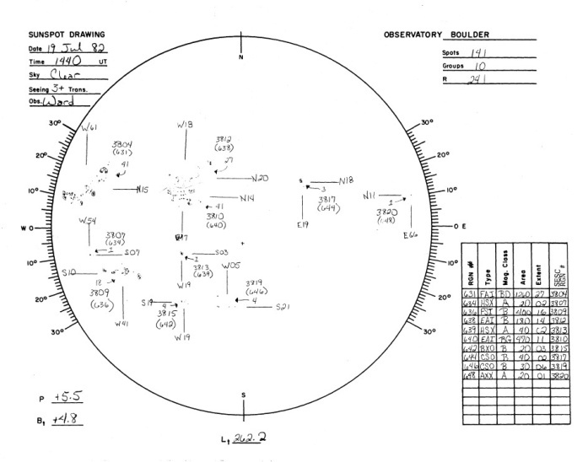The NGDC data holdings currently include a variety of solar observations and drawings that complement the Sac Peak sunspot drawings. Shown below is a daily sunspot drawing from the Boulder Solar Observatory for 19 July 1982, an interval covered by the Sac Peak drawings. Comparisons between the Boulder and Sac Peak drawings show the overall similarity in the location of sunspot groups but also highlight dissimilarities which may be due to differences in observer interpretation, observation time of day and environmental conditions; i.e. the presence of clouds, limitations in atmospheric clarity, etc. Also available for this day were multiple sunspot reports from the USAF Solar Observing Optical Network (SOON) previously provided to NGDC by the Air Force Weather Agency. The SOON data are not shown here but are readily available from the NGDC STP website.

Other comparative datasets available through NGDC include full-sun synoptic drawings from the Wendelstein Solar Observatory and the Northwest Solar Observatory, composite solar drawings prepared by the NOAA Space Environment Center (now the Space Weather Prediction Center) and solar photographs recorded in both white light and at specific wavelengths of interest.